Sahib jabbal and M.Jean-Pierre

University of Kent

App personalisation

BuzApp Project Specification

|  |  |  |  |
| --- | --- | --- | --- |
| Version Control | | | |
| Version | Author | Comments | Date |
| V1 | Marc Jean-Pierre and Sahib Jabbal | First Version of Document | 10/10/17 |
| V2 | Sahib Jabbal | Second Version of Document | 23/10/17 |
| V3 | Marc Jean-Pierre | Third Version of Document | 30/10/17 |
| QA1 | Sahib Jabbal | Check Documentation if ok | 31/10/17 |
| V4 | Sahib Jabbal | References updated to Harvard style | 31/10/17 |
| QA2 | Sahib Jabbal | Check if document is ok | 01/11/17 |

**App Personalisation**

Mobile app personalisation is the process of building a mobile application that meets the needs of specific audiences of an application. In order to personalise the current version of BuzApp there are various concepts that need to be considered.

According to (Peri 2017), there are two main categories in which mobile application can be personalised;q

* Content personalised - Content personalisation allows the applications to look the same for all its users however, it can be personalised by ensuring the current location on a map
* Experience personalised - Experience personalisation is when an application changes to meet the needs of a user.

To personalise a mobile application in general, it is vital that while developing a mobile application, the users are considered and able to understand the needs of the users. This would ensure that the users would be engaged with the application and new users would be attracted to the application. Feedback from the users is useful as this allows the developers to use the feedback provided to improve the application further and personalise it further.

**Examples of how current travel apps have been personalised**

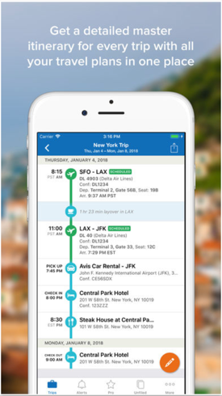TripIt

TripIt allows the application to integrate with the users mail inbox to dynamically create an itinerary that walks the user through the various steps of their trip. It knows where the user is and provides the unique details that the user would require while away, weather alerts.

United Airlines

United Airlines keeps user updated to flight changes and gate information, the application would know where you are supposed to be and when. While there’s little they can do about the Transport Security Administration, the application would make the rest of the airport experience efficient and easy for their users.

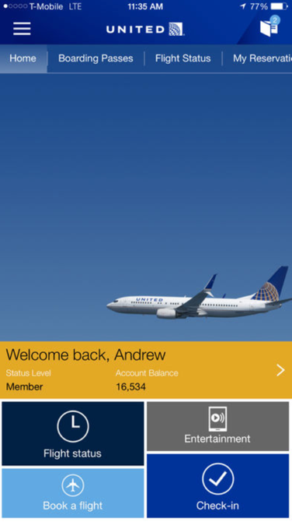

Citymapper

City mapper lets their users to identify their home, place of work and common destinations up to seven cities. This saves the users time from having to repetitively input the same data.

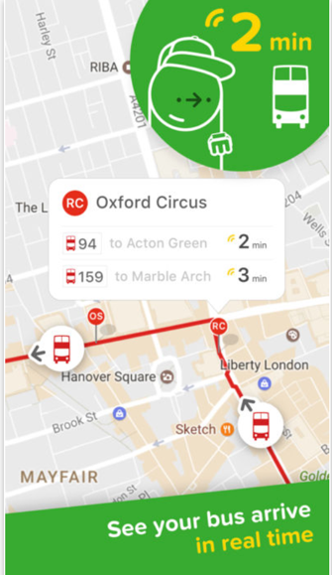

Waze

Waze integrates with calendars and contact information to send automatic push messages letting the users when they need to leave for their journey. The application warns the users about heavy traffic or other obstacles in advance.

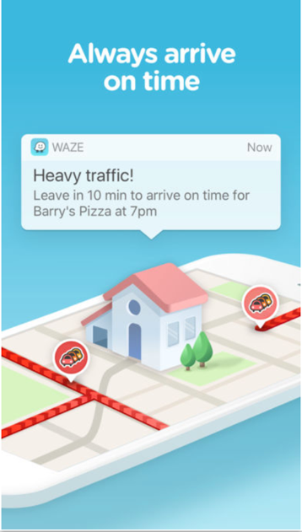

**Example of other personalised mobile application**

Foursquare

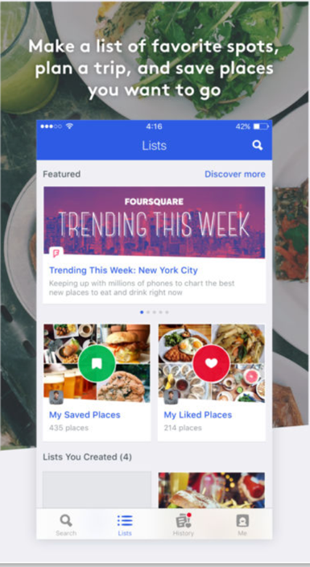Foursquare gets the location of users and provides a list of places near them based on their search. The application informs the user the time it would take to reach the restaurant. It also provides users to add photos, personal rating of the places from the users who have visited it. Users are able to save and like the places.

**Content and Experience Personalisation**

Based on the new features that we are planning on adding to our application, they can be divided into either content or experienced personalisation. The features that fall under content personalisation are nearest, recent and favourite stops, journey planner and push notifications. This is because the app will look the same to all users and will be either based upon location, or previous views and selections. Therefore, the calendar and inbox showcasing the issues with buses in the users favourites will be experience personalisation. This is because BuzApp will be changing to fit the needs of the user as they would be linking their personal calendar to the application and gaining information as a result of this.

**References**

1. 5 Examples of Travel Apps With Amazing Personalized Experiences Read more at https://www.business2community.com/mobile-apps/5-examples-travel-apps-amazing-personalized-experiences-01743255. (2017). [online] Available at: https://www.business2community.com/mobile-apps/5-examples-travel-apps-amazing-personalized-experiences-01743255#9uJZXC5MrxX0XofU.97 [Accessed 31 Oct. 2017].
2. Foursquare.com. (2017). *London | Food, Nightlife, Entertainment*. [online] Available at: https://foursquare.com/ [Accessed 31 Oct. 2017].
3. Marketo Marketing Blog - Best Practices and Thought Leadership. (2018). *3 Steps to Mobile App Personalization*. [online] Available at: https://blog.marketo.com/2016/06/3-steps-to-mobile-app-personalization.html [Accessed 31 Oct. 2017].
4. Optimizely.com. (2017). *App Personalization*. [online] Available at: https://www.optimizely.com/optimization-glossary/app-personalization/ [Accessed 31 Oct. 2017].
5. Pieri, S. and Pieri, S. (2017). *personalisation | Digital Marketing: What is it all about?*. [online] Blogs.brighton.ac.uk. Available at: http://blogs.brighton.ac.uk/digimarkets/tag/personalisation/ [Accessed 31 Oct. 2017].